HOMEWORK WEEK 3

- OOP stands for Object Oriented Programming. OOP is a programming which works around the concept of an object (instance of a class). There are four main principles in OOP:
  - Polymorphism
  - Encapsulation
  - Abstraction
  - Inheritance

We used Python before which is an OOP. As far as I remember we didn’t use the concept of object in our course very often but the easiest create an object, you need firstly to create a variable and assign this variable to a class.

However we coded before using the concept of class components especially for all unit tests.

- Polymorphism defines the ability of a programming language to interpret a single type entity (method, operator or object)differently which will result in different outputs/scenarios.

For example, in Python we have the function “lens()” which is an inbuilt polymorphic functions, Indeed, depends on the data types of the inputs, lens() will interpret differently and will show different responses.
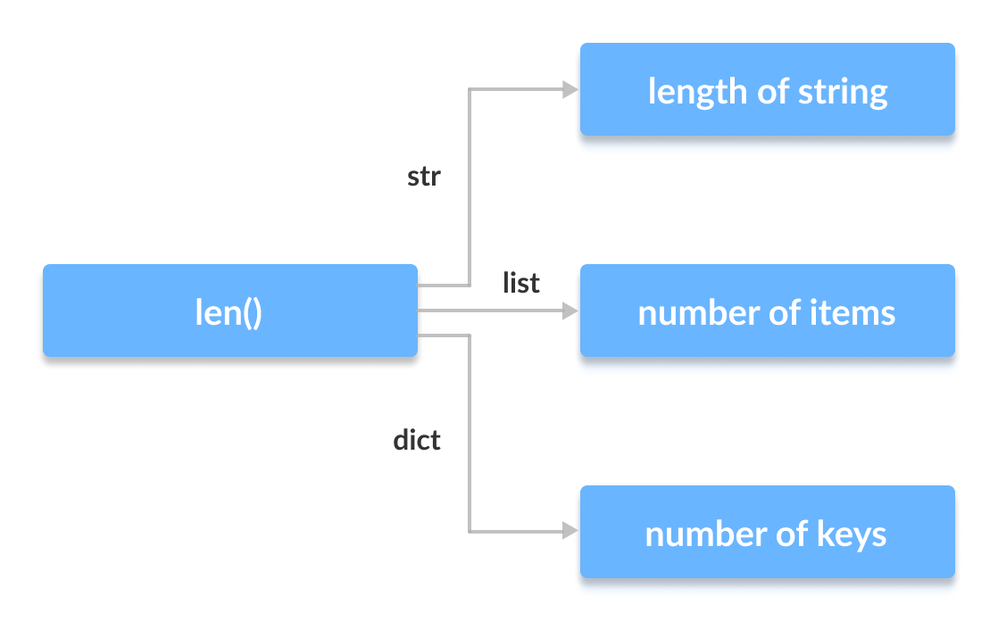

The advantages of the polymorphism :
  - is being time saving: to write, test and implement the codes and classes once but being reusable multiple times.
  - Is being easy to debug: as the codes used less classes, it will be easier to target the bugs.

The disadvantages of the polymorphism:
- is being difficult to code
- is leading to performance issue as the machine needs to interpret the polymorphic code before running and displaying the output

- Abstraction defines a programming concept where only essential /relevant attributes is shown to the user and all internal unnecessary details and information are hidden from the user. There are two types of abstraction : data abstraction and process abstraction.

The advantages of the abstraction:
  - is reducing coding complexity
  - is increasing the security of the code (more difficult to hack when you don’t see all details/informations)

The disadvantages of the abstraction:
- is being difficult to code
- is leading to performance issue depend on the number of abstraction layers

- Inheritance defines a programming concept where a child class will inherit all methods and properties from a parent class
The advantages of the inheritance:
  - is being time saving: to write, test and implement the codes and classes once but being reusable multiple times.

The disadvantages of the inheritance:
  - lack of independence in the code: the child class is coupled with the parent class which means the child class can’t be used independently
  - is leading to performance issue as the inheritance execution takes times

- Encapsulation defines a programming concept to store/place a pack of data and methods into a class, It restricts the access of the data and methods.
The advantages of the encapsulation:
  - is increasing the security of the code ( more difficult to hack from outside and prevent accidental modification)
  - is disconnecting objects into class from unnecessary data

The disadvantages of the encapsulation:
  - is being difficult to code
  - is leading to performance issue as it slows the execution

  - Agile development is an approach for development to deal with and being successful in an uncertain environment where the requirements and solutions evolve through continuous planning/learning/improvement/team collaboration,
There are four principles in agile:
        - individual and interactions over process and tools
        - Working software over comprehensive documentation
        - Customer collaboration over contract negotiation
        - Responding to change over following an adaptable plan

The advantages of the Agile development:
  - is increasing the quality of the result as the project is split into small steps call sprints
  - allows a better adaptability to change and better/faster response to change
  - issues will be detected and therefore fixed faster
  - allows everyone to be involved in each step of the project, there is more visibility of the project for all stakeholders

The disadvantages of the Agile development:
  - is more difficult to measure and see concrete progress in the project as the project is splitting into small steps
  - is more effort and time consuming as the team/client must continuously interact
  - is increasing the time of project delivery as we are continuously trying to adapt/improve the result therefore it is difficult to define the timeline of the project
  - is difficult to define the total project budget and cost

  - Waterfall development is an approach for sequential development. Indeed, the waterfall development is an linear project plan where the team can’t work on different phases of the project at the same time. The main phases in Waterfall development are :

    - Requirements
    - Design
    - Implementation
    - Verification or testing
    - Deployment and maintenance

The advantages of the Waterfall development:
  - is easy to measure and see concrete progress as the team can’t work on a new project phase as long as the phase they are currently working is not complete
  - is less effort and time consuming as the team is following a linear plan where there is no continuous improvement mindset
  - is easy to define the budget and cost of the project
  - is easy to define the timeline of the plan and when the project will be complete

The disadvantages of the Waterfall development:
  - there is less adaptable and will have difficulties to respond fast to a a change (for example if the clients need to change the requirements as they didn’t fully know what they wanted at the start)
  - there is less team collaboration therefore not all stakeholders are involved in every steps of the project.
  - The dependency of phases can create issues. For example, if there is a delay on the current phase, all the phases will be delayed

  - The Waterfall development is considered as the traditional development where there is defined requirements/budget/time/plan while the Agile development is a more free development approach where there is no defined requirements/budget/time/plan etc as it is a continuous improvement project.
The choice of the approach to use depend on the project itself. If It is a strict project with time/cost/budget/ restrictions and limitations, therefore the Waterfall development should be chosen. However, if there is no particular deadline/cost/budget restrictions, the Agile development should be chosen.

